**The hall of entrepreneurs, patrons and benefactors of the 19th - early 20th century**

1. **Study the information about the Khludovs in the showcase, then read and complete the text with the given words and word combinations:**

peasants handicraft joint-stock textile

sewerage flax spinning intermarried shareholders

cotton yarn philanthropic benefactors

**THE KHLUDOVS**

The Khludovs are prominent Russian entrepreneurs of the 19th and the early 20th centuries, founders of a group of large **1)** …………………… enterprises, public cultural figures, well-known patrons and **2)** ……………………...

They came from **3)** …………………. of the Riazan province, started with family **4)** …………………. production and trade. In 1835, the Khludov brothers established a trading house under their own name, and 10 years later they launched one of Russia’s first **5)** ………………….. factories in Iegorievsk on a machine base. Also, in 1860 in Iaroslavl, the Khludovs created and developed a large-scale textile production, including **6)** …………………. and weaving, and since 1890, cotton spinning and weaving.

Together with other entrepreneurs the Khludovs were the founders and **7)** …………………… in Russia’s largest Krenholm manufactory in Narva.

The third generation of the Khludovs, having **8)** …………………… with the Mamontovs, the Morozovs, the Naidenovs, the Prokhorovs, the Vostriakovs and the Lukutins, becomes a serious participant of the financial activities of the Moscow Commercial Bank and **9)** …………………. companies Morozovskaia Tverskaia, Prokhorovskaia Trekhgornaia and others.

The Khludovs’ **10)** ………………….. and charitable activities were diverse and significant. Near their factories they built residential towns for workers and employees, which had convenient houses, schools, hospitals, theatres and libraries. There was central heating, **11)** ………………….., running water in the houses.

**Answer the questions:**

1. Where did the Khludovs come from?

2. What are the main fields of their business activities?

3. What conveniences were provided for the workers and employees at Khludovs’ factories?

________________________________________________________________________________________________________________________________________________________________________________________________________________________________________________________________________________________________________________________________________________________________________________________

1. **Find the representatives of the Khludov family among the portraits:**
2. 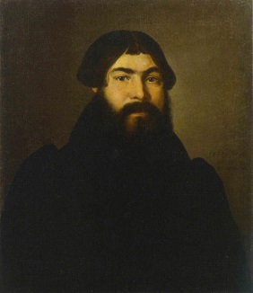 2) 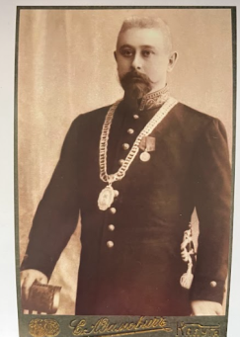 3) 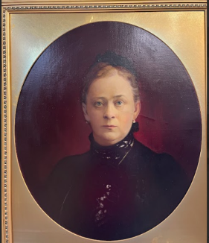

4) 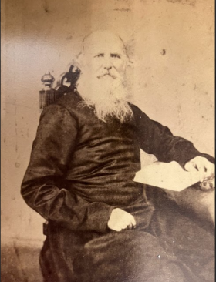 5) 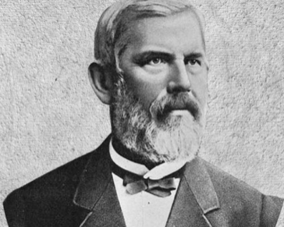 6) 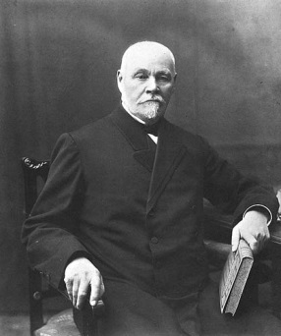

**3. Study the information in the showcase and name the spheres of charitable activities of the family.**

_____________________________________________________________________________________________________________________________________________________________________________________________________________________________________________________________________________________________________________________________________________________________________________________________